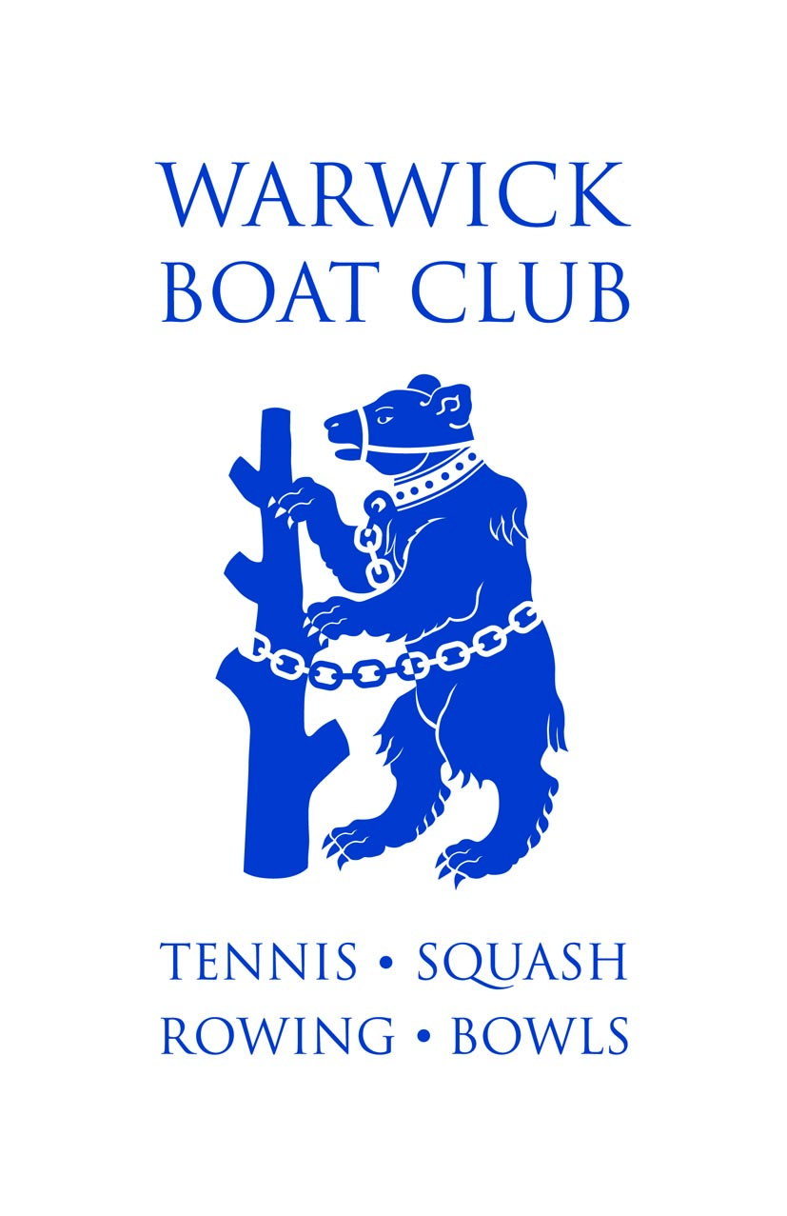
Warwick Boat Club Consent and Emergency Contact Form
Your details (if U18 must be the parent/carer / Emergency Contact)
Name:
Address:
Contact details: | Phone:  Mobile: | Email:
Details of the child / adult (if different)
Name:
Date of birth:
Address (if different from the parent/carer):
Contact details (if different from the parent/carer): | Phone:  Mobile: | Email:
Details of the event/trip / activity the child / adult will be attending

Activities
I give permission for the child / adult to:
Be involved in photography and/or filming. | Yes No
Travel by any form of public transport or in a motor vehicle. | Yes No
Other (please detail) | Yes No
It is a requirement of the Rowing Section that all members are able to swim 50m and tread water for 2 minutes in light clothing. The Club will regularly hold swim tests and training in capsize procedures.  Can your child swim 50 metres and tread water for 2 minutes in light clothing? | Yes No

Child / Adult Medical/Disability History
Does the child /adult have:
Any health needs (e.g. diabetes, asthma, epilepsy, allergies) that we should be aware of? |  | Yes No
Any access needs? |  | Yes No
Any religious or spiritual practices we should be aware of? |  | Yes No
Any dietary needs we should be aware of? |  | Yes No
Anything else which we should be aware of? |  | Yes No
If yes to any of the above, please provide full details e.g. time medication must be taken, if help is required to administer medication, etc. (please use additional paper if required).

2nd Emergency Contact Details (in addition to first Parent/Carer)

Name:

Relationship to the child or adult:

Address:
Contact details: | Phone:  Mobile: | Email:

Confirmation
Name of parent/carer or adult (print): |  |  | Date
Signature:
Consent valid for the following period (please circle) | This event only  1 week  1 month | 1 year  Period of Membership  Other (please detail):

